When the Bruises Can't Be Seen

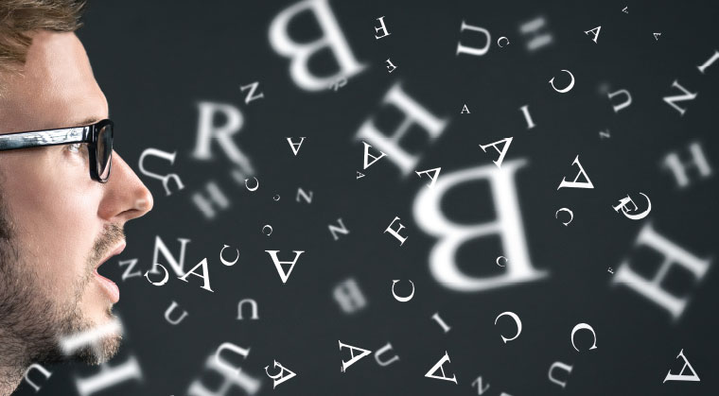
Mishnah Pirkei Avos 5:1
In ten utterances the world was created ...

#1
Sticks and stones may break my bones, but words can never hurt me.

Questions:
(a) What is your opinion about this popular saying?
(b) What’s worse – being hurt by harsh words or being hurt financially?
(c) How does American law treat harsh word versus financial assault?

Mishlei (Proverbs) 18:21
Death and life are in the power of the tongue.

Questions:
(a) How do you understand this statement?
(b) What could be the impact of painful words?

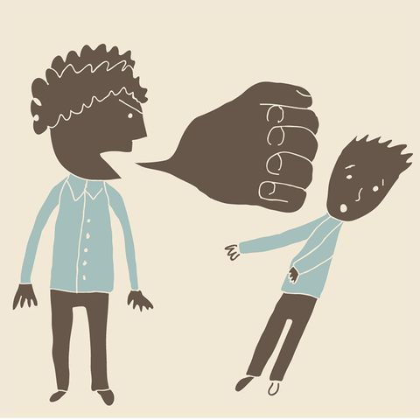

#2
Question: What is your opinion about the following cases - do they describe acceptable, proper, or unacceptable behavior?

(a) Sam is planning to play a practical joke on Jenn.
(b) Mrs. Smith, a public school teacher, asks her student Bill a question to which she knows he does not have the answer.
(c) Brian says to his sister: “This adversity you are suffering is really your fault because you acted incorrectly in another area.”
(d) Brandon is complementing Mitchell: “Who would have thought that you would get to where you are today!”
(e) Man, in a store to Steve: “Hey, remember me? I'm your dad's old college buddy. The pranks he used to pull - legendary! The trouble your father used to get into … I'm not even sure how he graduated! Take care. See you later.”
(f) Advertisements on notice boards in Israel often have the advertiser’s details written on paper tags at the bottom of the sign. They can be torn off by someone interested in the offer. You see a notice with none of its tags removed, so you pull one off in order to make the advertiser feel better that at least one person is interested.
(g) You to the seller: “How much do these shoes cost?”
You whisper to your friend: “I saw these shoes online for half the price. I just wanted to try them in the store. “

#3
Questions:
(a) What is the definition of verbal abuse?
(b) Would you categorize any of the above cases in #2 (above) as verbal abuse?

#4
Torah, Vayikra 25:17
Each of you shall not aggrieve his fellow, and you shall fear your G-d; for I am G-d, your Lord.
Talmud, Bava Metzia 58b
It refers to the prohibition against causing distress with one’s words.

Questions:
(a) Given the prohibition on verbal abuse, what is the appropriate response of a person who is the victim of such treatment? Is he also commanded not to use hurtful words in response to such an attack, or is the prohibition not to cause distress not applicable in this situation?
(b) If someone is being verbally abused - what advice would you give him/her about how they should deal with the situation?
(c) Why is the fear of G-d mentioned specifically in regards of how we speak to each other?

#5
Question: How do we avoid hurting others with words - intentionally or intentionally?

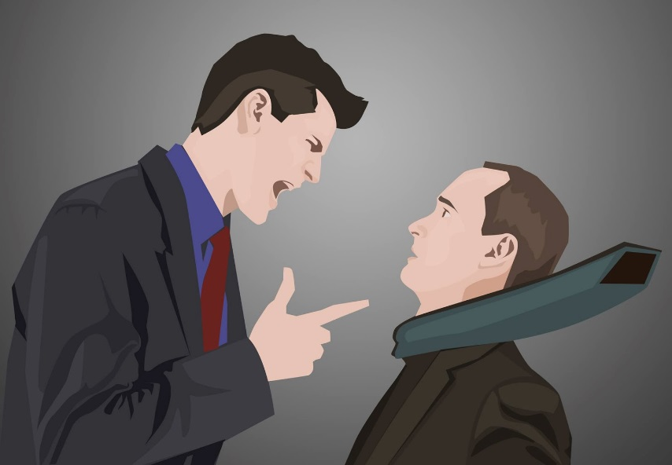
#6
Question: What's your takeaway from today's discussion?

